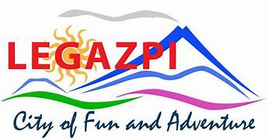
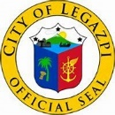
Republic of the Philippines
SANGGUNIAN PANLUNGSOD
LEGAZPI CITY

PEOPLE’S COUNCIL MEMBERSHIP FORM

Name of Organization: ________________________________________________

Address: __________________________________________________________

Contact No.: ________________ Email Address(optional): __________________

Date Organized: _______________ Date Registered: ____________________

Sector being represented: _____________________________________________

Services that the organization provides or can participate in:
______________________________________________________________________________________________________________________________________________________________________________________________________

Organizational Level:

BarangayChapter
Affiliate of a larger organization (identifyorganization):

Others (specify): ________________________________________

Local Special Body Membership, if any:

Local Development Council Local Health Board
Local School Board

Local Peace and Order Council

